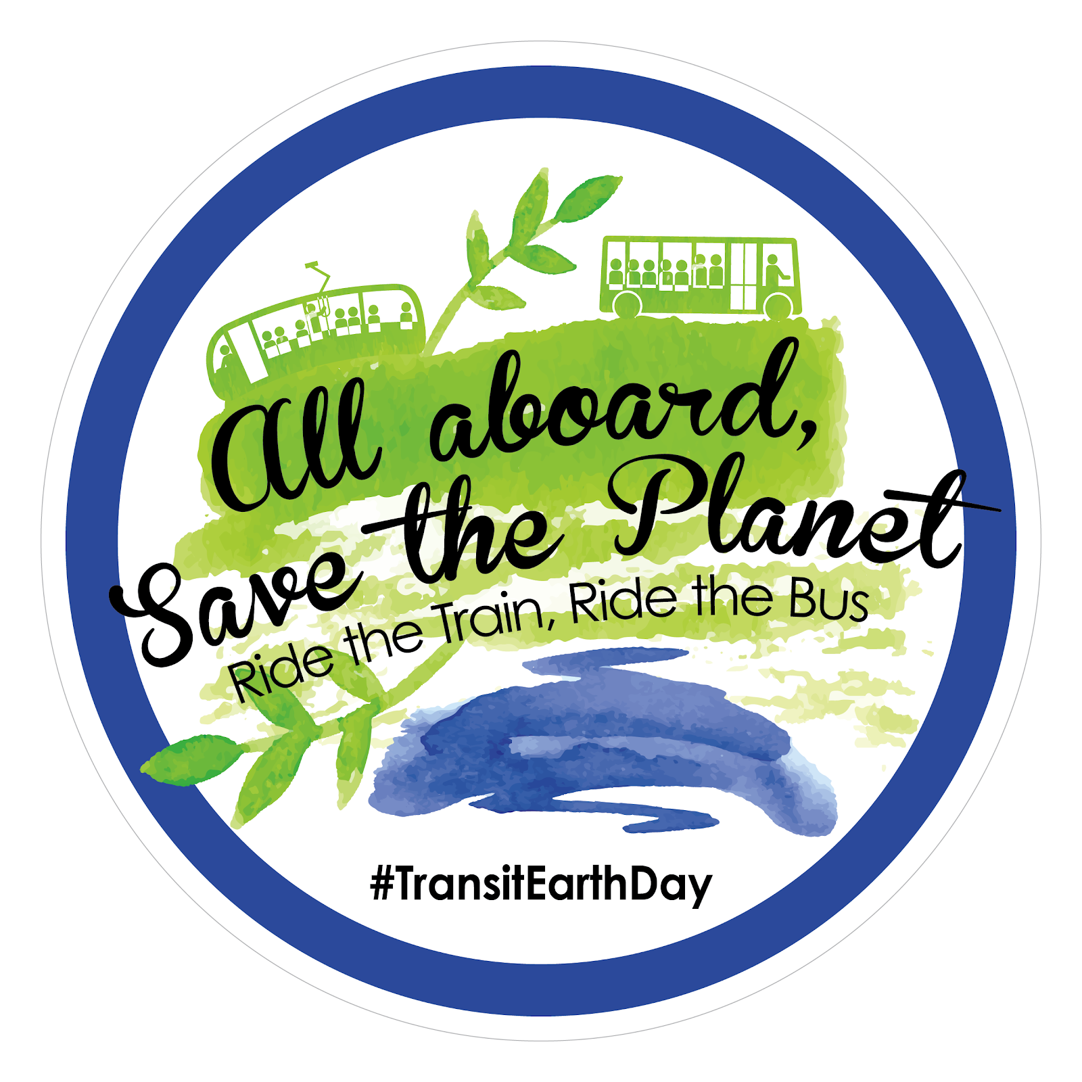

EARTH DAY TRANSIT EQUITY
ORGANIZING T OOLKIT

Welcome and Happy Earth Day!

Several national and locally-based unions and organizations are joining together to make sure that Transit Equity is a key part of this year’s Earth day celebrations. We are planning a week of activities beginning April 16 to promote public transit as a civil right and a strategy to combat climate change. We seek to highlight the rights of all people to high-quality public transportation powered by clean/renewable energy. We recognize that we need a “full spectrum” just transition from the fossil fuel economy (energy, energy efficiency, transportation, waste, agriculture…) to clean, renewable energy as part of confronting the climate crisis. Increasing, non-fossil fuel, public transportation is a foundation to achieving this transition.

A just transition requires that we uphold worker and civil rights. This means that everyone should have the right and access to free (or at least affordable) public transportation regardless of age, race, or class. It also includes supporting the rights of workers to organize in the sectors that will build, operate and maintain public transportation infrastructure, as well as provide the services.
We also want to promote the principle of public vs. private investment in public transportation - the need for public resources and infrastructure (public transportation, public regulation of our energy systems, a stronger public sector overall, etc.), to lead and administer the transition to fossil fuel free public transportation.
This Organizing Toolkit will provide you with resources that will help you to organize your own activities during the week of April 16 through Earth Day on April 22, 2018 and ways to connect to the broader network of organizations that will be taking action.

Here are the resources that you will find in this toolkit:
Pg. 4 – What you can do
Pg. 5 – Op-Ed Template
Pg. 7 – Draft Resolution
Pg. 9 – Graphics and Social Media
Pg. 10 – Informational Palm Card

If you are planning an activity between April 16 and 22 please let us know! Or for more information, please contact TransitEarthDay@labor4susainability.org

Website: labor4sustainability.org/transit-equity

Amalgamated Transit Union
Americans for Transit
Chainbreaker Collective (Santa Fe, NM)
Georgia Stand-Up
Institute for Policy Studies
Jobs with Justice
Labor Community Strategy Center (Los Angeles)
Labor Network for Sustainability
Music City Riders United
NAACP
Organizing People Activating Leaders (Portland, OR)
Partnership for Working Families
Pittsburghers for Public Transit
Sierra Club

What you can do
A main goal for Earth Day is to support the efforts of many people who are already working to support public transit in their communities. Thousands of people in the U.S. are already organizing campaigns through their unions and organizations. We would love to highlight your work and connect it to the broader network of activities during the week of April 16-22, 2018. Please email us at:
TransitEarthDay@labor4sustainability.org or call Michael Leon Guerrero, Labor Network for Sustainability (424) 243-6543 for more information.
Here are some ideas of activities you can organize on Earth Day whether you are part of an existing campaign or not:

EDUCATE
- Convene an educational event about public transit as a civil right and as a key strategy to confront climate change.
- Wear a button or sticker to your workplace showing support for public transit as a civil right.
- Get an op-ed published in your local newspaper.
AGITATE
- Organize a direct action to support a local campaign for quality public transit for all.
ORGANIZE
- Get your union local, organization city council, transportation board and others to pass a resolution supporting public transportation as a civil right.
- Get your union to establish a climate action committee.

Op-Ed Template
An Appeal for Transit Equity

This April 22nd marks 48 years since the first Earth Day in 1970. Over the years, some have made efforts to recycle, install energy saving light bulbs and more efficient water fixtures, use more insulation and even turn down your thermostat. This year, we are asking you to participate in the most effective strategy to reduce individual emissions: take the bus, subway or train every day.

- One person switching to public transportation can cut carbon emissions by more than 4,800 pounds per year.
- Public transportation saves 37 million metric tons of carbon emissions every year and saves 4.2 billion gallons of gasoline annually.
- Public transit produces significantly less greenhouse gas emissions per passenger mile than single-occupancy vehicles: Heavy rail – 76% less, Light rail – 62% less, and Bus – 33% less.
- Mass public transit reduces the number of vehicles on the road, mitigating emissions caused by traffic congestion.
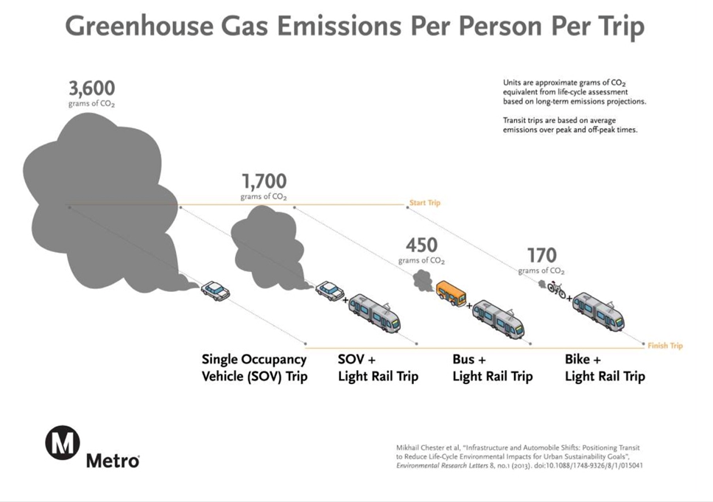
By using public transportation, we can support efforts to cut emissions and protect the environment. This effort far exceeds other household energy saving activities. Investing in public transit creates healthier communities, as riders walk to and from bus stops, trains and helps combat the growing problem of traffic congestion plaguing cities across North America.

Unfortunately, our urban transit systems have grown far worse in the past decades. Privatization has led to running companies not for public service but for corporate profit. If companies can’t make a profit running buses for less affluent workers and neighborhoods, they often fail to buy new buses, let their equipment run down, make schedules that are impossible for drivers to meet – and then shut down the lines on the grounds that they don’t pay for themselves! Our cities are full of transit deserts where residents and workers have to spend hours walking and taking circuitous routes simply to get to their jobs, see their families, buy groceries, or get to a medical appointment. According to U.S. Census data, nearly half of American households do not have access to any public transportation.

In honor of Earth Day, we continue our fight for climate justice and transit equity. A group of organizations including the Amalgamated Transit Union, the Labor Network for Sustainability, Jobs with Justice, and the Institute for Policy Studies are participating in Earth Day on (Insert Date) to take action for civil rights and a safe climate future.

- Climate justice: The lives and futures of Americans and all people are threatened by devastating
climate change. As a U.S. federal court recently declared, all people have a right to a stable climate. That will require a rapid cut in the burning of the fossil fuels that emit the greenhouse gases (GHGs) that cause climate change. And one of the easiest, fastest, and cheapest ways to do that is public transit run on clean, renewable energy.

- Transportation justice: Every person in every neighborhood regardless of age, race, class, gender, or disability should have the right to safe, convenient transportation at an affordable cost.

- Workers justice: The workers who build public transit infrastructure, who operate and maintain the systems, and who get us where we need to go have the right to safe, decent working conditions, family- supporting incomes, and the right to choose to be represented by a union

- Community justice: Pollution from cars, trucks, and other transportation emit a large proportion of our dangerous pollution, causing asthma and many other life-threatening conditions. Replacing cars and trucks with public transit is far healthier for individuals and communities. A just transit system will provide all communities fair access to the jobs and amenities of metropolitan areas.

For More Information: transitearthday@labor4sustainability.org

Draft Resolution for Adoption by Union Locals and Internationals, Community Organizations, Religious Congregations, and Local Governments

WHEREAS Earth Day is an important annual reminder of the critical importance of preserving a livable planet for humanity, and has historically been associated with the rise of environmental consciousness in the United States; and

WHEREAS humanity is faced with the growing crisis of climate change, with record-breaking temperatures, with consequences including sea level rise, prolonged drought, more frequent wildfires, more severe storms and flooding, and spread of diseases; and

WHEREAS the effects of climate change disproportionately hurt workers, people of color, and poor people, and constitute a human rights crisis of our time, as seen so vividly in the recent devastation from hurricane impacts in Texas, Puerto Rico, the U.S. Virgin Islands, and elsewhere; and

WHEREAS the overwhelming scientific consensus attributes the warming trend to human emissions of greenhouse gases, mainly from the combustion of fossil fuels such as oil, gas, and coal; and

WHEREAS it is essential for the survival of humanity to drastically cut our emissions of greenhouse gases and convert our economy to renewable non-emitting energy sources; and

WHEREAS emissions from the transportation system are a major part of greenhouse gas emissions; and

WHEREAS transitioning our transportation system from excessive automobile dependence to public transit, especially electrified public transit with electricity from renewable sources, is key to transitioning our economy from fossil fuels to renewable energy and cutting our greenhouse gas emissions; and

WHEREAS the growth of public transit will also reduce automotive pollutants such as nitrogen oxides and particulate matter that have the worst impacts on communities of color and low-income communities; and

WHEREAS unequal access to public transit based on race, income, and disability have persisted to this day, and have to a degree become worse, with cuts in public funding for transit and consequent fare increases in many transit systems; and

WHEREAS the required expansion of public transit to address the climate crisis provides an unprecedented opportunity to transform our transit systems to be affordable and accessible, so that people of color, low-income people, people with disabilities, and other marginalized populations have full access to the benefits of public transit; and

WHEREAS public transit jobs in the United States have historically been good jobs that paid family-supporting wages, but in parallel to the cuts in public funding for transit and the trend of increasing fares, there is a growing marginalization of transit workers, who are facing worsening work conditions and erosion of their collective bargaining rights; and

WHEREAS the required expansion of public transit to address the climate crisis also provides an unprecedented opportunity to reverse this assault on workers by creating a large number of good, high-skill, family-supporting transit operation jobs, as well as construction jobs for building new transit facilities; and

WHEREAS affordable, reliable public transit is an essential public service, on par with utilities such as water and electricity; and

WHEREAS increased community access to public transit, reduction in racial, economic and other disparities in access to transit and clean air and in the burden of climate change impacts, and increased opportunities for employment in good jobs, form a key part of a “just transition” from a carbon-intensive, fossil-fuel based, highly unequal economy to a clean, renewable energy based, just economy;

THEREFORE, BE IT RESOLVED that the (insert name of city/union/organization here) supports the call to observe a Week of Action on Public Transportation as a Climate and Environmental Solution between April 16 and 22, 2018; and

RESOLVED that the (insert name of city/union/organization here) will use the Week of Action to highlight the vital role that can be played by expansion of public transit in the required shift from a climate-destroying fossil fuel powered economy to a climate-protecting, renewable-powered economy, with a just transition for communities and workers; and

RESOLVED that the (insert name of city/union/organization here) will draw attention to the continuing racial, economic, and other inequalities in access to adequate public transit, and the need for affordable and accessible transit, through the Week of Action; and

RESOLVED that the (insert name of city/union/organization here) will form a Climate Action Committee to plan and implement equitable, just climate solutions at the level of the organization; and

RESOLVED that the (insert name of city/union/organization here) will support legislation at the Federal, state, and local levels that:

- Increases public funding for transit, including funding to expand transit systems, especially in underserved neighborhoods, communities of color, low-income communities, and communities burdened by pollution;
- Uses a part of the increased public funding to offset the need for fare increases, and reduce (or at least cap) fares;
- Eliminates or reduces fares for particular populations such as seniors, people with disabilities, and K-12 students;
- Increases the accessibility of public transit for people with disabilities;
- Increases job opportunities in transit system operation as well as construction, and ensures that the new jobs pay family-supporting wages, provide good benefits, and give workers the opportunity to organize a union and bargain collectively without employer pressure and intimidation; and
- Prioritizes the hiring of low-income people, people of color, people from communities currently underserved by transit and/or overexposed to vehicular and other forms of pollution, people with disabilities, workers displaced from polluting industries, formerly incarcerated people, and other marginalized populations for transit operation and construction jobs.
GRAPHICS AND SOCIAL MEDIA

Logo

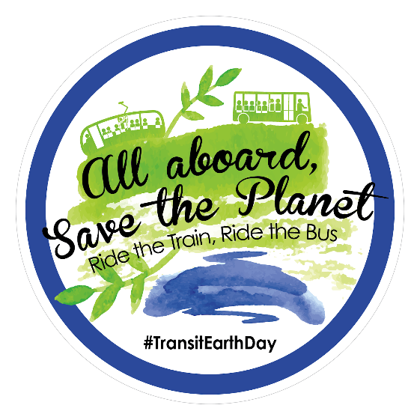

Hashtag: #TransitEarthDay

Twitter Accounts

Sponsoring Organizations
Labor Network for Sustainability: @LN4S
Amalgamated Transit Union: @ATUComm
Jobs with Justice: @jwjnational
Partnership for Working Families: @P4WF
Institute for Policy Studies: @IPS_DC
Labor Community Strategy Center: Their Website
Bus Riders Union: @BusRidersUnion
Chainbreaker Collective: Facebook Account

Website: labor4sustainability.org/transit-equity

